Golden Copy for Extracting Data for all kinds of EAS Templates

**Prepared for:**



**Safe-Guard**

Two Concourse Parkway, Suite 500

Atlanta, Georgia 30328

**Version Control:**

|  |  |  |  |  |  |  |
| --- | --- | --- | --- | --- | --- | --- |
| **S. No** | **Version** | **Comments** | **Created By** | **Created On** | **Reviewed By** | **Reviewed On** |
| 1 | 1.0 | Initial Version | Madhana Ilango | 08/12/2019 | Arvind Chandrasekaran | 08/14/2019 |
| 2 | 1.1 | Refined Version | Madhana Ilango | 08/21/2019 | Arvind Chandrasekaran | 08/14/2019 |
| 3 | 1.2 | Added CFC Rate Templates Section | Madhana Ilango | 08/27/2019 | Arvind Chandrasekaran |  |
| 4 | 1.3 | Added Surcharge Template Section | Nivedhitha Akhilesh | 04/10/2020 | Arvind Chandrasekaran |  |
| 5 | 1.4 | Added Product Exclusion Section | Arvind Chandrasekaran | 06/20/2020 |  |  |
| 6 | 1.5 | Added Dealer Tier Mapping Section | Nandini Ramachandrappa | 11/30/2020 | Arvind Chandrasekaran | 12/01/2020 |
| 7 | 1.6 | Added Dealer Section | Madhana Ilango | 03/16/2021 | Arvind Chandrasekaran | 03/16/2021 |
| 8 |  |  |  |  |  |  |

**Client Name** : Safe-Guard

**Module Name** : EAS

**SQL Server Details :**

|  |  |
| --- | --- |
| **Server Name** : QTSPRODEASDB1 & other testing environments.  **DB Name** : SGEAS_DIFF | **Authentication Type** : Windows  **Permissions Needed** : EXECUTE on SPs, SELECT on related tables and views. |

**Project Description :**

*Safeguard EAS Client Portal had been developed and deployed as the next generation Solutions in the mid of 2017. The platform is based on a newly enhanced datastore, with added flexibility & capability for product configuration and rate management. This would mean, this application is scalable by number of clients and flexible on implementation of latest requirements & trends on Auto Insurance Industry.*

*The SG EAS Client Portal since deployment, is being used for clients, such as Porsche, Bentley, Lamborghini, Quality Shield US & Canada. Subsequent to that the features were implemented for a fully branded suite of products for Volkswagen Credit, Inc (“VCI”) for Volkswagen, Audi, and Ducati dealers in the United States. We did implement new automobiles such as VROOM, Rumble-On, Harley Davidson, etc. There are few new ones on the pipeline such as Ashton Martin, etc*

*This Document explains the data extraction for EAS Rate Template. We are having different SPs for different tabs in EAS Rate Template. Detailed description of each SPs are as follows.*

**A. Tabs in EAS Rate Template:**

EAS Rate Template is main set of Rating provided for the slew of services within Safe Guard

1. Product Plan SKU (Stock Keeping Unit).
2. Vehicle Classing
3. Client Pricing
4. Rate System Mapping
5. Rate System State Association
6. Surcharge

**B. Tabs in PPM Template**

PPM Template is part of separate Template Type, for the Pre-Paid Maintenance Product & Claim Services

1. PPM (Pre-Paid Maintenance) Coverage
2. PPM Services

**C. Tabs in CFC Rate Template**

CFC Rate template will not be part of EAS Rate template. CFC Template will be provided only when there is rate change for CFC Dealers.

1. CFC

**D. Tabs in Product Exclusion Template**

Product Exclusion Template is used for special Exclusions being applied on the Rating application for a provided Program, Product Code and Plan Code (if need be)

1. Product Exclusion

**E. Tabs in Dealer Tier Mapping Template**

Dealer Tier Mapping is continuation template for Inclusion of Dealer against the Product Service Rate Tier. Its needed as the subsequent templates to that of the PPM Templates

1. Dealer Tier Mapping

**F. Tabs in Dealer List Template**

Dealer List Mapping is template for Inclusion of Dealer details for the provided OEM/Program. Its needed as a prior template to that of Rate System Mapping and Rate System State Association

1. Dealer List

**Section A: (EAS Rate)**

1. **Product Plan SKU**

**Description :** By passing the program ID, Product Code and Sale Date as input, all the available **SKUs** with Product_Plan_Code, Term_from, Term_To, Deductible, Odometer Ranges, etc. within the date range will return

**SP Name** : getSKUByProgram

*exec getSKUByProgram @Program_Id,@Product_Code,@ad_sale_Date,@as_debug*

**Input Parameters :**

|  |  |  |  |
| --- | --- | --- | --- |
| **Parameter** | **Data Type** | **Description** | **Is Nullable** |
| @Program_ID | Bigint | ID of the program for which we are going to extract the data. | No |
| @Product_Code | Varchar(20) | Product Code for which we extract the SKUs | No |
| @ad_Sale_Date | Date | Date on which the product plans were available for selection. | No |
| @as_debug | Varchar(5) (Default to PROD) |  | Yes |

Ex : **exec getSKUByProgram 20285,’AUMD’,’08/12/2019’,’PROD’.**

**Illustration on the output:**

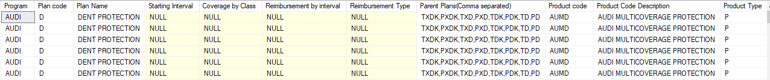

1. **Vehicle Classing**

**Description :** By passing the program ID, Product Code as input, all the available **Classing records**  with Classing method, Class code, Make, Model, etc. will return.

**SP Name** : getProgramVehicleClassing

*exec getProgramVehicleClassing @Program_Id,@Product_Code,@ad_sale_Date,@as_debug*

**Input Parameters :**

|  |  |  |  |
| --- | --- | --- | --- |
| **Parameter** | **Data Type** | **Description** | **Is Nullable** |
| @Program_ID | Bigint | ID of the program for which we are going to extract the data. | No |
| @Product_Code | Varchar(20) | Product Code for which we extract the Classing records | No |
| @ad_Sale_Date | Date | Date on which the Classing were available for selection. | No |
| @as_debug | Varchar(5) (Default to PROD) |  | Yes |

Ex : **exec [getProgramVehicleClassing] 20285,'AUMD','08/12/2019'**

**Illustration on the output:**

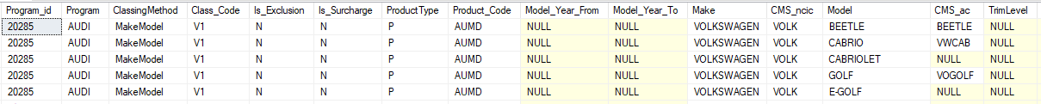

1. **Client Pricing**

**Description :** By passing the program ID, Product Code and Sale Date as input, all the available **pricing records**  with Rate method, Amount, Agent code, SKU, etc. will return within the date range

**SP Name** : getEASRateByProgramOrDealer

*exec getEASRateByProgramOrDealer @Program_Id,@Product_Code,@ad_sale_Date,@cms_dealer_number,@as_debug*

**Input Parameters :**

|  |  |  |  |
| --- | --- | --- | --- |
| **Parameter** | **Data Type** | **Description** | **Is Nullable** |
| @Program_ID | Bigint | ID of the program for which we are going to extract the data. | No |
| @Product_Code | Varchar(20) | Product Code for which we extract the pricing records. | No |
| @ad_Sale_Date | Date | Date on which the pricing was available for selection. | No |
| @cms_dealer_number | Varchar(8) | Dealer Number for which we need the active pricing records. | Yes |
| @as_debug | Varchar(5) (Default to PROD) |  | Yes |

Ex : **exec [getEASRateByProgramOrDealer] 20285, ‘AUMD’, ‘08/12/2019’, NULL,’PROD’**

**Illustration on the output:**

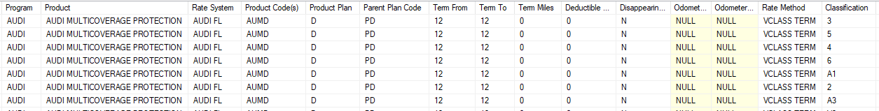

1. **Rate System Mapping**

**Description :** By passing the program ID, Product Code as input, all the available dealer rate system mapping will return for that product.

**SP Name** : getRateSystemMapping

*exec getRateSystemMapping @Program_Id,@Product_Code,@ad_sale_Date,@as_debug*

**Input Parameters :**

|  |  |  |  |
| --- | --- | --- | --- |
| **Parameter** | **Data Type** | **Description** | **Is Nullable** |
| @Program_ID | Bigint | ID of the program for which we are going to extract the data. | No |
| @Product_Code | Varchar(20) | Product Code for which we extract the dealer and rate system mapping. | No |
| @ad_Sale_Date | Date | Date on which the rate system mappings were available for selection. | No |
| @as_debug | Varchar(5) (Default to PROD) |  | Yes |

Ex : **exec [getRateSystemMapping] 20285,'AUMD','08/12/2019'**

**Illustration on the output:**

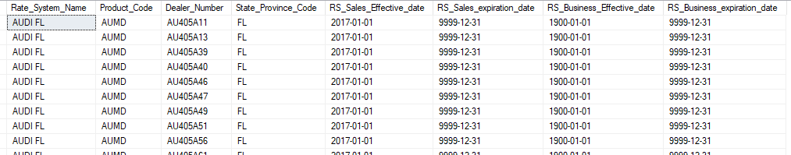

1. **Rate System State Association**

**Description :** By passing the program ID as input, we will get the list of rate system and states to which the rate system is mapped.

**SP Name** : getRateSystemStateAssociation

*exec getRateSystemStateAssociation @Program_Id,@Product_Code,@ad_sale_Date,@as_debug*

**Input Parameters :**

|  |  |  |  |
| --- | --- | --- | --- |
| **Parameter** | **Data Type** | **Description** | **Is Nullable** |
| @Program_ID | Bigint | ID of the program for which we are going to extract the data. | No |
| @Product_Code | Varchar(20) | Product Code for which we extract the rate system and state mapping. | No |
| @ad_Sale_Date | Date | Date on which the rate system state association were available for selection. | No |
| @as_debug | Varchar(5) (Default to PROD) |  | Yes |

Ex: **exec [getRateSystemStateAssociation] 20285,'AUVS','08/12/2019’**

**Illustration on the output:**

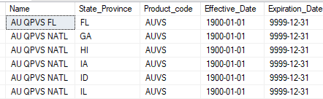

1. **Surcharge**

**Description :** By passing the program ID, Product Code and Sale Date as input, all the available **Surcharge records**  with Surcharge Name, Amount, Rate System Name, Version Name etc. will return within the date range.

**SP Name** : getSurchargeByProgram

*exec* **getSurchargeByProgram** *@Program_Id,@Product_Code,@ad_sale_Date,@as_debug*

**Input Parameters :**

|  |  |  |  |
| --- | --- | --- | --- |
| **Parameter** | **Data Type** | **Description** | **Is Nullable** |
| @Program_ID | Bigint | ID of the program for which we are going to extract the data. | No |
| @Product_Code | Varchar(20) | Product Code for which we extract the Surcharge records. | No |
| @ad_Sale_Date | Date | Date on which the Surcharge was available for selection. | No |
| @as_debug | Varchar(5) (Default to PROD’) |  | Yes |

Ex : exec [getSurchargeByProgram] 20295,'VRVS','2020-02-05', 'PROD'

**Illustration on the output:**

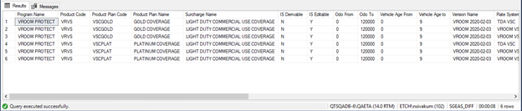

**Section B:(PPM)**

1. **PPM Coverage:**

**Description :** By passing the program ID, Product Code as input, all the coverages available for this product will return.

**SP Name** : getPPMCoverage

*exec getPPMCoverage @program,@product_code,@plan_code,@ad_Sale_Date',’@as_Debug'*

**Input Parameters :**

|  |  |  |  |
| --- | --- | --- | --- |
| **Parameter** | **Data Type** | **Description** | **Is Nullable** |
| @Program | Varchar(50) | Program for which we are going to extract the data. | No |
| @Product_Code | Varchar(20) (If we don’t know the product code, then -1 can be given as input). | Product Code for which we extract the Coverages | No |
| @Plan_Code | Varchar(50) (If we don’t know the plan name, then -1 can be given as input). | Plan Code for which we extract the available coverages. |  |
| @ad_Sale_Date | Date | Date on which the coverages were available for selection. | No |
| @as_debug | Varchar(5) (Default to PROD) |  | Yes |

Ex : **exec getPPMCoverage 'HARLEY DAVIDSON SERVICES USA','HDUP','HU05K2','08/13/2019','PROD'**

**Illustration on the output:**

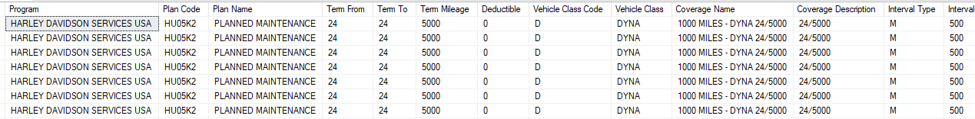

1. **PPM Services:**

**Description :** By passing the program ID, Product Code and Plan Code as input, all the services available for this coverage will return.

**SP Name** : getPPMServices

*exec getPPMServices @program,@product_code,@plan_code,@ad_Sale_Date,@as_Debug*

**Input Parameters:**

|  |  |  |  |
| --- | --- | --- | --- |
| **Parameter** | **Data Type** | **Description** | **Is Nullable** |
| @Program | Varchar(50) | Program for which we are going to extract the data. | No |
| @Product_Code | Varchar(20) (Product Code or -1(in case we don’t pass product code)) | Product Code for which we extract the Services available. | No |
| @Plan_code | Varchar(30) (Plan Code or -1(in case we don’t pass plan code)) | Plan Code for which we need the services. |  |
| @ad_Sale_Date | Date | Date on which the services were available for selection. | No |
| @as_debug | Varchar(5) (Default to PROD) |  | Yes |

Ex : **exec getPPMServices 'HARLEY DAVIDSON SERVICES USA','HDUP','HU35K2','08/13/2019','PROD’**

**Illustration on the output:**

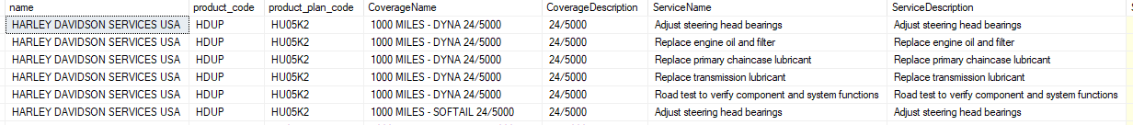

**Section C: (CFC)**

1. **CFC Rate Template:**

**Description :** By passing the program and product code as input, all the CFC Pricing available for that product will return.

**SP Name :** getCFCRatesByProgram

*exec getCFCRatesByProgram @Program, @Product_Code, @ad_sale_date, @as_debug*

**Input Parameters :**

|  |  |  |  |
| --- | --- | --- | --- |
| **Parameter** | **Data Type** | **Description** | **Is Nullable** |
| @Program | Varchar(50) | Program for which we are going to extract the data. | No |
| @Product_Code | Varchar(20) (Product Code or -1(in case we don’t pass product code)) | Product Code for which we extract the CFC rates available. | No |
| @ad_Sale_Date | Date | Date on which the rates were available for selection. | No |
| @as_debug | Varchar(5) (Default to PROD) |  | Yes |

**Ex : exec getCFCRatesByProgram 'AUDI','AUCE','08/01/2019',’PROD’**

**Illustration on the output :**

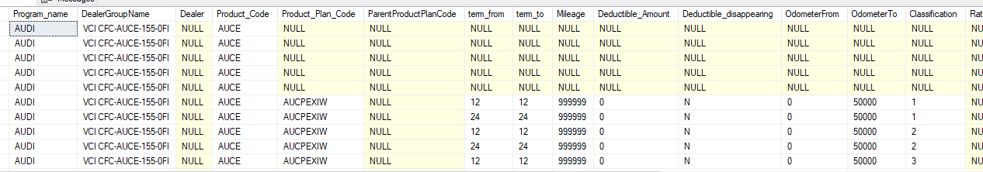

**Section D: (Product Exclusion)**

1. **Product Exclusion**

**Description :** By passing the program ID, Product Code and Sale Date as input, all the available **Product Exclusion records** with Program, Product Code, Plan Code, Exclusion type, Is After Sale, Vehicle Condition, Vehicle Type, Make, Blank In Service Date, etc. will return within the date range.

**SP Name** : getProgramProductExclusion

*exec* **getProgramProductExclusion** *@Program_Id, @Product_Code, @Product_Plan_Code, @ad_sale_Date,@as_debug*

**Input Parameters :**

|  |  |  |  |
| --- | --- | --- | --- |
| **Parameter** | **Data Type** | **Description** | **Is Nullable** |
| @Program_ID | VARCHAR(50) | ID of the program for which we are going to extract the Exclusion data. | No |
| @Product_Code | Varchar(20) | Product Code for which we extract the Surcharge records. | Yes |
| @Product_Plan_Code | Varchar(20) | Product Plan Code for which we extract the Exclusion records | Yes |
| @ad_Sale_Date | Date | Date on which the Exclusion was available for selection. | No |
| @as_debug | Varchar(5) (Default to PROD) |  | Yes |

Ex : **exec [getProgramProductExclusion] 'PRIME AUTOMOTIVE PROTECT’,'PRVS',NULL, '2020-05-01', 'PROD'**

**Illustration on the output:**

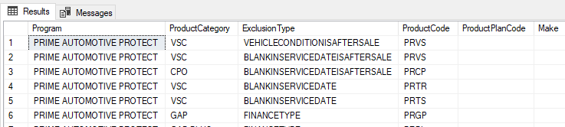

**Section E:(Dealer Tier)**

1. **Dealer Tier Mapping**

**Description :** By passing the program ID as input, we will get the list of Dealers and products to which the Tier is mapped, to the PPM Templates.

**SP Name** : getDealerTier

*exec* getDealerTier *@ai_Program_Id, @ai_Product_Code, @ad_sale_Date, @as_debug*

**Input Parameters :**

|  |  |  |  |
| --- | --- | --- | --- |
| **Parameter** | **Data Type** | **Description** | **Is Nullable** |
| @ai_program_ID | Bigint | ID of the program for which we are going to extract the data. | No |
| @ai_Product_Code | Varchar(20)(Default to –1) | Product Code for which we extract the Dealer and Tier mapping. | No |
| @ad_Sale_Date | Date | Date on which the Dealer and Tier association were available for selection. | No |
| @as_debug | Varchar(5) (Default to PROD) |  | Yes |

Ex: **exec [getDealerTier] 20276,'HDUP','11/30/2020’, ‘PROD’**

**Illustration on the output :**

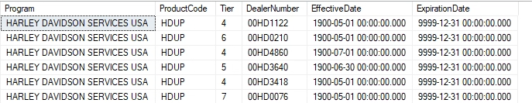

**Section F:(Dealer)**

1. **Dealer**

**Description :** By passing the program ID as input, we will get the list of Dealers and details to which the given Program.

**SP Name** : getDealerByProgram

*exec* getDealerByProgram *@ai_Program_Id, @as_debug*

**Input Parameters :**

|  |  |  |  |
| --- | --- | --- | --- |
| **Parameter** | **Data Type** | **Description** | **Is Nullable** |
| @ai_program_ID | Bigint | ID of the program for which we are going to extract the data. | No |
| @as_debug | Varchar(5) (Default to PROD) |  | Yes |

Ex: **exec [getDealerByProgram] 20276, ‘PROD’**

**Illustration on the output :**

**Disclaimer:**

*This document is intended to be exhaustive enough, to bring all the details needed for Data Extraction for EAS module – templates. For the Client - Safe Guard this project is maintained by Mayura Technologies. Any changes, misleading information and missing details needed to be reported to* ***‘iteasecomteam@sgintl.com’***